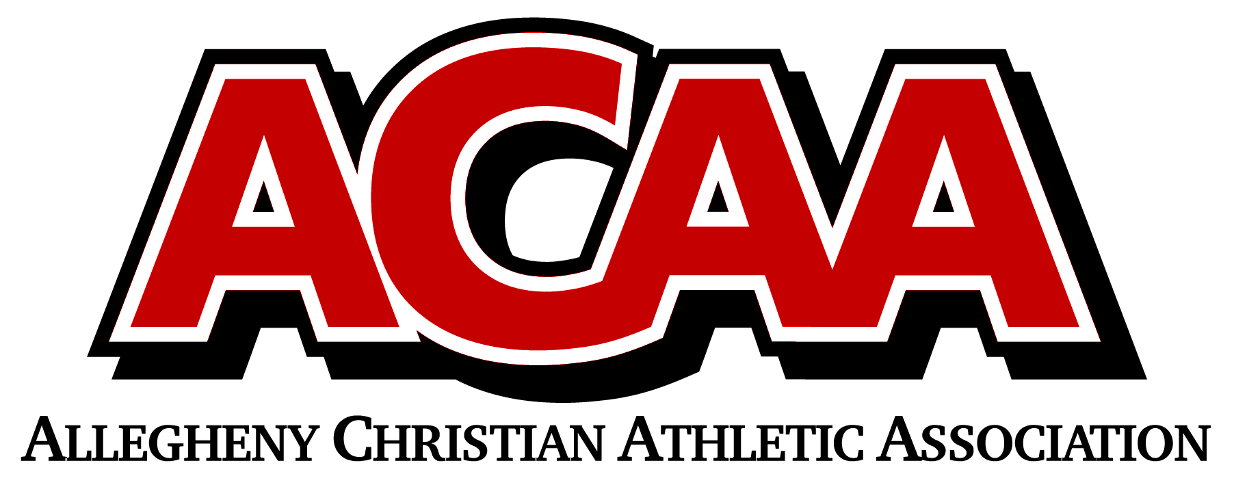

ACAA Pregame Soccer Sportsmanship Message
"ACAA requires all officials to enforce good sportsmanship for coaches, athletes, and spectators. Actions meant to demean opposing athletes, spectators, or officials are not in the highest ideals of Christian education and will not be tolerated in today’s event. All words and actions should show mutual respect.
Coaches please certify to the officials that your athletes are legally equipped and uniformed according to NFHS rules and ACAA adoptions."

